AI StudyBuddy – An AI-Powered Learning and Exam Preparation Assistant

Project Title

AI StudyBuddy – An AI-Powered Learning and Exam Preparation Assistant
Team Details
Team ID : SWTID-2026-5461
Team Leader:
TAMILSELVI K - tamilselvitnnsisters@gmail.com
Team Members:
SALMA BEGUM J- shakila2810@gmail.com
SWATHI D - swathiaarthi2006@gmail.com
ROSHINI P - roshiniparthiban2310@gmail.com

Description
- AI StudyBuddy is an AI-powered platform that simplifies learning.
- Uploads study materials and generates summaries.
- Creates flashcards, quizzes, and personalized study plans.
- Built using Node.js, Express.js, and MongoDB.
- Ensures security using JWT, RBAC, and bcryptjs.
- Integrates Google Gemini AI for content generation.
- Organizes study materials for efficient learning and revision.

Scenario-Based Case Study

Background
Roshini P is a competitive exam aspirant preparing for government and entrance examinations. She finds it challenging to manage a large amount of study material, revise important topics, and practice questions within a limited preparation time.

Problem
Roshini P faces several challenges during her competitive exam preparation:
- Difficulty understanding lengthy study materials.
- Time-consuming note and summary preparation.
- Difficulty creating flashcards and practice questions.
- Lack of personalized study plans.
- Difficulty organizing study materials in one place

Solution
AI StudyBuddy addresses the challenges of time-consuming manual note preparation, unorganized study materials, and ineffective exam preparation by providing an integrated AI-based learning solution. The platform automates the conversion of lengthy study materials into manageable learning resources, enables students to assess their understanding through self-evaluation tools, and supports systematic exam preparation through personalized scheduling.

Usage

Student Usage
Students register and log in to AI StudyBuddy to access its AI-powered learning features. After authentication, they can upload study materials or enter text and select the required functionality, such as generating summaries, creating flashcards, taking quizzes, or receiving personalized study plans. The generated resources can be reviewed and saved for future revision, helping students organize their exam preparation efficiently.

Administrator Usage
Administrators manage user accounts, monitor platform activities, and maintain the overall functionality of the application. They oversee system usage, monitor AI service operations, and ensure the smooth and secure functioning of the platform.

Outcome
AI StudyBuddy provides an intelligent and organized learning environment that simplifies the preparation process for competitive examinations. By automating the creation of summaries, flashcards, quizzes, and personalized study plans, the application reduces the time and effort required for manual study preparation.

As a result, AI StudyBuddy helps students organize their study materials, improve revision efficiency, assess their knowledge, and manage their preparation through a centralized and personalized learning platform.

Software Requirements
- Operating System: Windows 10/11, macOS, or Linux for cross-platform development.
- Node.js (v16 or above): Runtime environment for executing backend logic and server-side operations.
- npm (v8 or above): Package manager for installing and managing project dependencies.
- Express.js: Web framework for developing RESTful APIs and handling client-server communication.
- MongoDB: NoSQL database for storing user information, study materials, summaries, flashcards, quizzes, and study plans.
- Mongoose ODM: Provides schema validation, data modeling, and database interaction.
- Google Gemini AI API: Generates AI-powered summaries, flashcards, quizzes, and personalized study plans.
- Postman: API testing tool for verifying backend endpoints, authentication, and request-response handling.
- Visual Studio Code: Code editor for developing, debugging, and maintaining the application.

Hardware Requirements
- Processor: Intel Core i5 (8th Generation or above), AMD Ryzen 5, or equivalent.
- RAM: 8 GB minimum; 16 GB recommended for smooth development and database operations.
- Storage: At least 1 GB of available disk space for project files, dependencies, and study resources.
- Internet Connection: Required for accessing the Google Gemini AI API and other online services

Epic 1: Project Architecture

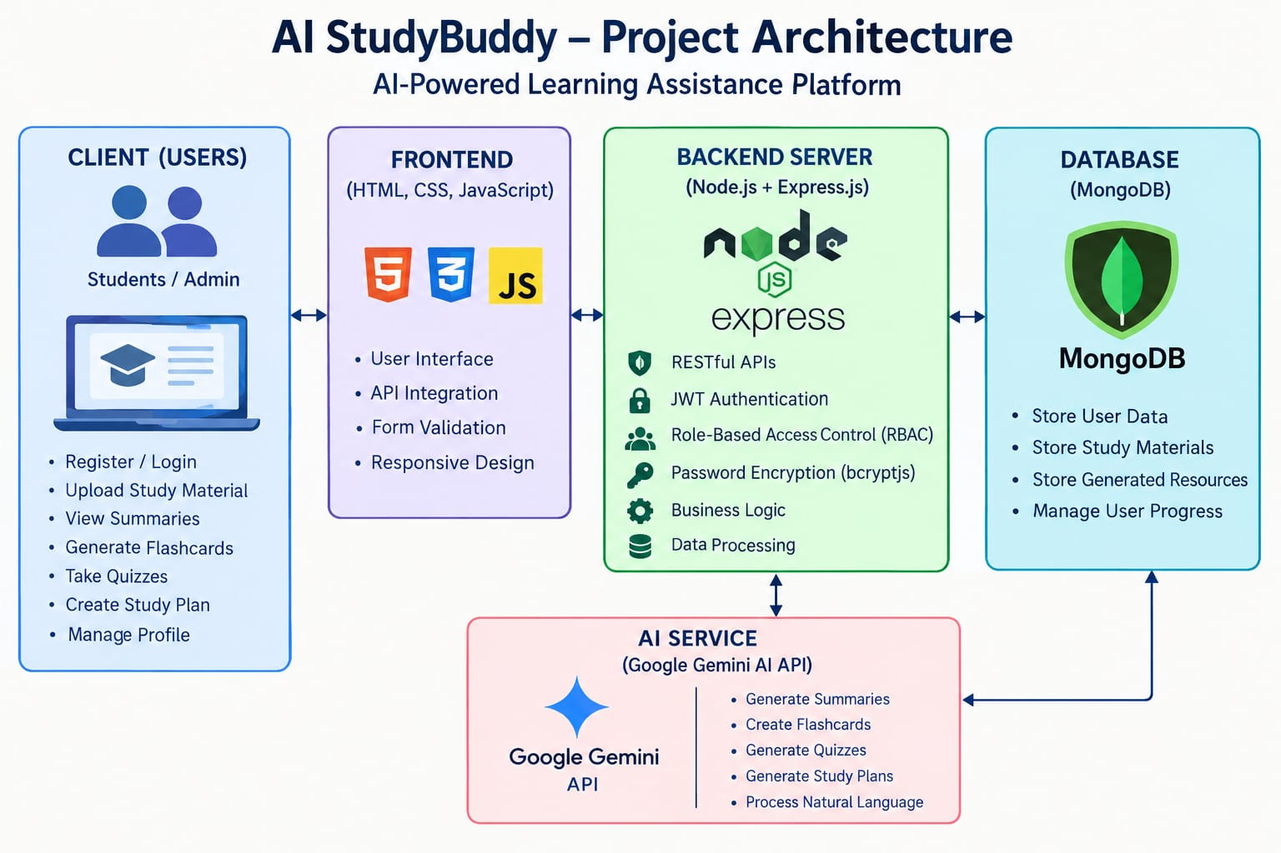

Description
The architecture separates authentication, request handling, business logic, AI services, and database operations into independent modules. This modular design improves maintainability, simplifies debugging, and supports future enhancements to the application's learning features.

Components Definition
- Express Server: Handles user requests and manages API communication.
- Authentication Middleware: Verifies user identity using JWT and protects restricted routes.
- Route Handlers: Manage authentication, study materials, and AI feature requests.
- Database Layer: MongoDB, integrated with Mongoose ODM, stores user details, study materials, generated learning resources, and study plans.

Entity-Relationship (ER) Diagram Description
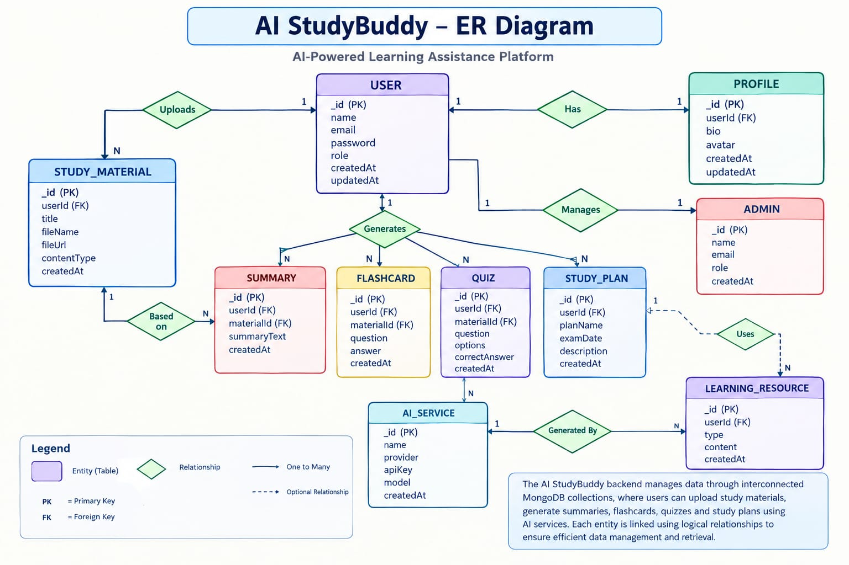

User Entity
Stores the details of registered students and administrators.

Attributes:
- _id (Primary Key – ObjectId)
- name (String, Required)
- email (String, Required, Unique)
- password (String, Hashed)
- role (String – Student/Admin)
- createdAt (Date)

Study Material Entity
Stores study materials uploaded by students for AI-powered learning.
Attributes:
- _id (Primary Key – ObjectId)
- userId (Foreign Key → User)
- title (String)
- subject (String)
- content (String)
- createdAt (Date)

Summary Entity
Stores AI-generated summaries of uploaded study materials.

Attributes:
- _id (Primary Key – ObjectId)
- userId (Foreign Key → User)
- material Id (Foreign Key → Study Material)
- summary (String)
- createdAt (Date)

Flashcard Entity
Stores AI-generated flashcards for revision and practice.

Attributes:
- _id (Primary Key – ObjectId)
- userId (Foreign Key → User)
- material Id (Foreign Key → Study Material)
- question (String)
- answer (String)
- createdAt (Date)

Quiz Entity
Stores AI-generated quizzes based on uploaded study materials.

Attributes:
- _id (Primary Key – ObjectId)
- userId (Foreign Key → User)
- material Id (Foreign Key → Study Material)

- questions (Array of quiz questions and options)
- correctAnswers (Array of correct answers)
- createdAt (Date)

Study Plan Entity
Stores personalized study plans generated by AI to help students prepare for exams.

Attributes:
- _id (Primary Key – ObjectId)
- userId (Foreign Key → User)
- studyPlan (String or Array of study tasks)
- examDate (Date)
- createdAt (Date)

Result Quiz Entity
Stores students' quiz attempts and performance details.

Attributes:
- _id (Primary Key – ObjectId)
- userId (Foreign Key → User)
- quizId (Foreign Key → Quiz)
- score (Number)
- totalQuestions (Number)
- completedAt (Date)

Key Relationships
- User → Study Material (One-to-Many): A user can upload and manage multiple study materials.
- Study Material → Summary (One-to-Many): A study material can have one or more AI-generated summaries.
- Study Material → Flashcards (One-to-Many): A study material can generate multiple flashcards for revision and practice.
- Study Material → Quiz (One-to-Many): A study material can generate multiple quizzes containing questions based on the uploaded content.
- User → Study Plan (One-to-Many): A user can generate multiple personalized study plans for different subjects or exam schedules.
- User → AI Resources (One-to-Many): All AI-generated summaries, flashcards, quizzes, and study plans are associated with the user who created them.

- Quiz → Quiz Result (One-to-Many): A quiz can have multiple quiz results from different attempts by students.

Key Features

The AI StudyBuddy backend provides intelligent learning assistance through secure and scalable REST APIs. The major features of the system are as follows:
- Secure User Authentication: Implements JWT-based authentication and password hashing using bcryptjs to ensure secure user access.
- Study Material Management: Allows students to upload, store, and manage study materials for AI-powered learning.
- AI Summary Generation: Uses the Google Gemini API to generate concise and easy-to-understand summaries from uploaded study content.
- AI Flashcard Generation: Automatically creates question-and-answer flashcards to support revision and active recall.
- AI Quiz Generation: Generates quizzes based on uploaded study materials to help students assess their knowledge.
- AI Study Plan Generation: Creates personalized study plans based on students' learning goals, subjects, and examination schedules.
- Quiz Performance Tracking: Stores quiz scores and results to help students monitor their learning progress.
- Role-Based Access Control (RBAC): Provides different access permissions for Students and Administrators to support secure system management.
- MongoDB Data Storage: Uses MongoDB and Mongoose to store user details, study materials, summaries, flashcards, quizzes, and study plans.
- REST API Integration: Uses Express.js and Node.js to handle requests and connect the frontend with backend services.

Roles and Responsibilities

Student
Students use AI StudyBuddy to prepare for competitive examinations and improve their learning. They can create an account, upload study materials, and use AI-powered tools to generate summaries, flashcards, quizzes, and personalized study schedules.

Administrator
The administrator manages the AI StudyBuddy platform and its users. The administrator can view registered user details, manage student accounts, control access permissions, and monitor system activities. The administrator also helps maintain the security, reliability, and proper functioning of the application.

User Flow
The AI StudyBuddy application starts when a student or administrator registers or logs in using their credentials. After successful authentication, the system verifies the user's role and redirects them to the appropriate dashboard. Students can upload their study materials and select the learning tool they want to use. The system processes the uploaded content through the Google Gemini AI API to create summaries, flashcards, and quizzes. Students can also generate personalized study plans based on their examination goals and available preparation time.

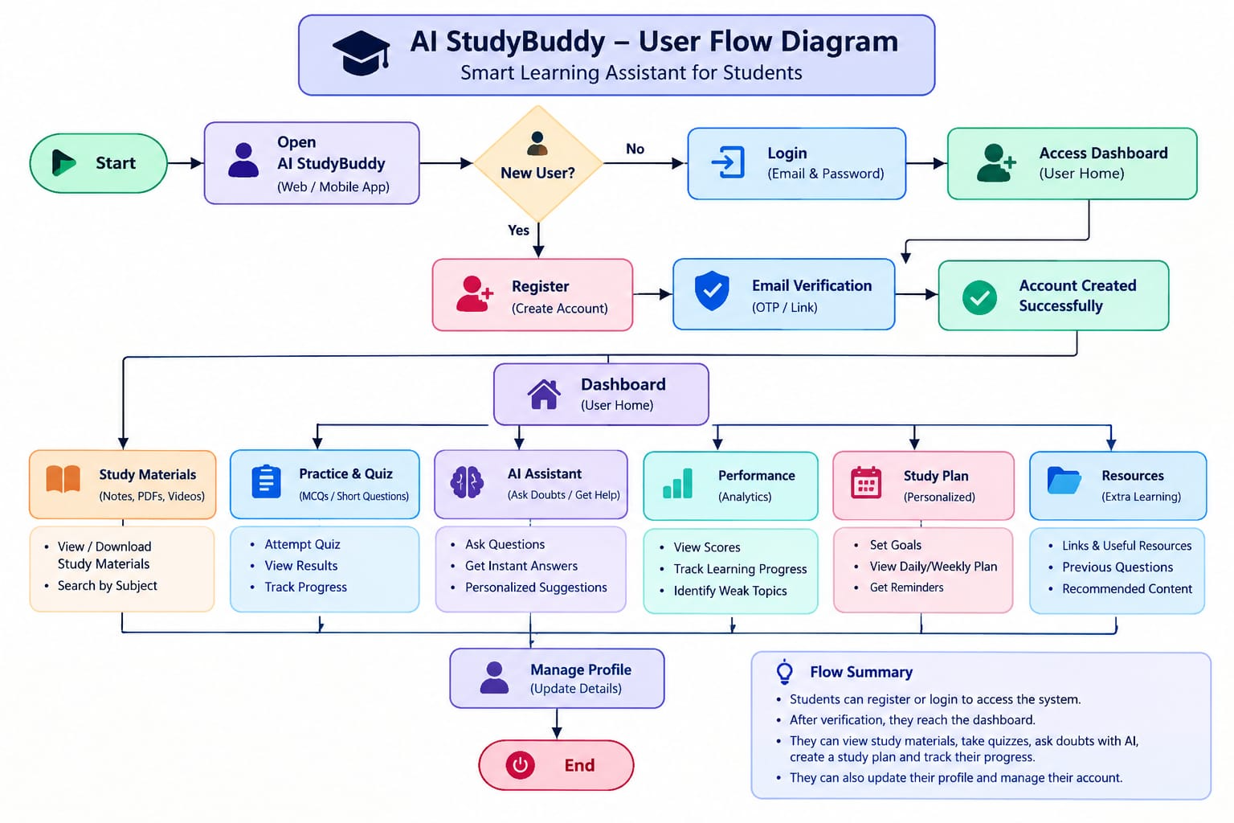
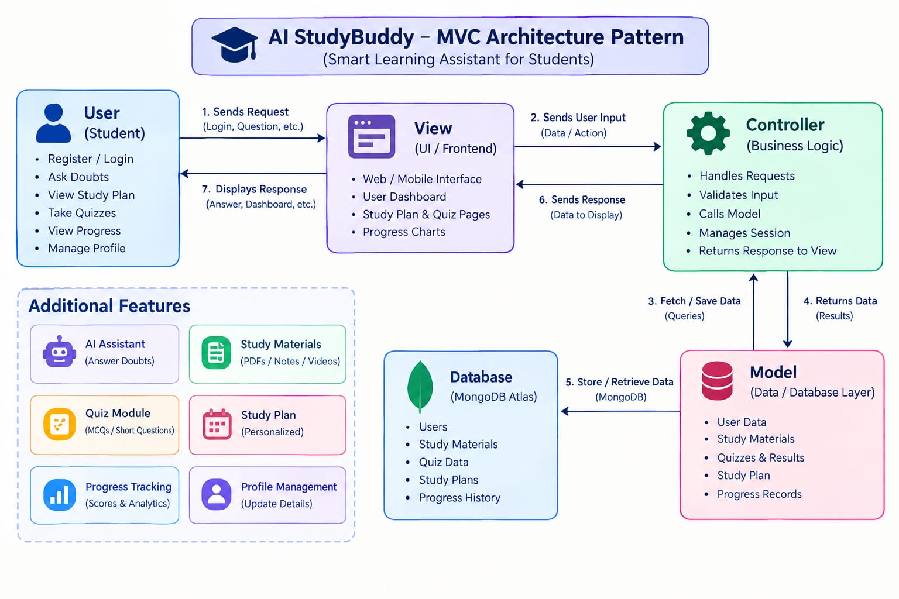
The AI StudyBuddy backend follows the Model-View-Controller (MVC) architecture to separate data management, API communication, and business logic. This makes the application modular, maintainable, and scalable.
M
odel Layer (Data Layer)
The Model layer defines the MongoDB collections using Mongoose schemas. It is responsible for managing user information, uploaded study materials, and AI-generated learning resources while ensuring data validation and database interactions.
View Layer (API Response Layer)
Since AI StudyBuddy is a backend REST API, there is no traditional user interface in the View layer. Instead, the API returns structured JSON responses to the React frontend, allowing users to interact with the application through REST endpoints.
Controller Layer (Business Logic)
The Controller layer processes incoming API requests, validates user input, performs authentication and authorization, communicates with the database models, invokes the Google Gemini AI service when required, and returns the appropriate response to the client.
MVC Benefits
The MVC architecture separates data management, business logic, and client communication into independent components. This improves code readability, simplifies debugging and testing, and allows new features to be integrated without affecting existing modules.

Epic 2: Project Setup and Configuration
Creating the Project Folder
- Create a new folder named AI StudyBuddy .
- Open the project folder in Visual Studio Code.
- Initialize the project using Node.js and install the required dependencies.
Project Initialization
Open the project folder in the VS Code terminal and execute:
npm init -y
Install the required dependencies:
npm install express mongoose bcryptjs jsonwebtoken cors dotenv multer @google/genai
Install Nodemon for development:
npm install --save-dev nodemon
Create the Following Files
- index.js
- .env
- package.json
- .gitignore
Create the Following Folder Structure

Environment Configuration
Create a .env file in the project root and configure the required environment variables.
PORT=5000
MONGO_URI=your_mongodb_connection_string
JWT_SECRET=your_jwt_secret
GEMINI_API_KEY=your_gemini_api_key
Epic 3: Backend Development
The AI StudyBuddy backend is developed using Node.js, Express.js, and MongoDB, following a modular architecture. The application separates routing, controllers, middleware, models, and utility modules to improve code maintainability and scalability. The backend exposes secure REST APIs for authentication, study material management, AI-powered content generation, and administrative operations.
Backend Structure

Core System Script Implementations
1. Application Entry Point (index.js)
The index.js file serves as the main entry point of the application. It initializes the Express server, loads environment variables, configures middleware, establishes the MongoDB connection, registers API routes, and starts the server after a successful database connection.

2. Database Connection (src/utils/db.js)
This module establishes a connection between the application and MongoDB using Mongoose. It ensures that the backend communicates with the database before processing any client requests.

3. Authentication Middleware (src/middleware/auth.js)
The authentication middleware verifies JWT access tokens for protected routes. It authenticates users before granting access to secured APIs and includes role-based authorization to restrict administrative operations.

4. AI Integration (src/utils/gemini.js)
This utility integrates the backend with the Google Gemini 2.5 Flash API. It sends prompts to the AI model and returns generated responses for summaries, flashcards, quizzes, and study plans.

5. File Upload Middleware (src/middleware/upload.js)
The upload middleware handles study material uploads and validates incoming files before they are processed by the backend.



Backend Development Demo:
AI_Studybuddy_Backend_Demo.mkv

Epic 4: Database Configuration
The AI StudyBuddy backend uses MongoDB as its primary NoSQL database and Mongoose ODM for data modeling and schema validation. MongoDB stores user information, uploaded study materials, and AI-generated learning resources in a structured manner. Mongoose simplifies database operations by providing schemas, validation rules, and efficient query handling.
Configure MongoDB
Install Mongoose using the following command:
npm install mongoose
Create Database Connection
Before performing any database operations, establish a connection between the backend and MongoDB using Mongoose. The connection module is initialized during server startup to ensure reliable communication with the database.
Mongoose Schema Definitions
1. User Schema (models/User.js)
The User schema stores authentication and profile information for registered users. It includes fields such as name, email, password, and role. Passwords are securely encrypted before being stored in the database.

2. Study Material Schema (models/Material.js)
The Study Material schema stores the learning content uploaded by users. This content acts as the input for AI-powered features such as summaries, quizzes, flashcards, and study plans.

Database Collections
The AI StudyBuddy database consists of the following collections:
- Users – Stores user account and authentication details.
- . Study Materials – Stores uploaded learning materials.
API Route Interface Endpoints
The backend exposes RESTful APIs to interact with the database and AI services.
1. Authentication APIs
Handles user registration, login, JWT authentication, and protected route access.
2. Study Material APIs
Allows users to upload, retrieve, update, and manage study materials.
3. AI Feature APIs
Provides endpoints for:
- AI Summary Generation
- AI Flashcard Generation
- AI Quiz Generation
- AI Study Plan Generation
4. Administrative APIs
Provides administrator-only endpoints for managing users and monitoring system activities.
Epic 5: Project Execution
The AI StudyBuddy backend can be executed locally using Node.js. Before running the application, ensure that MongoDB is running and the required environment variables are configured correctly. The backend exposes REST APIs that can be tested using Postman or Thunder Client.
Running the Backend Server
Install all required dependencies:
npm install
Start the development server:
npm start
After successful execution, the server connects to MongoDB and starts listening for incoming API requests.
API Testing
The backend APIs can be tested using Postman.
1. User Registration
Registers a new user by accepting the required details and securely storing the encrypted password in the MongoDB database.
Endpoint:
POST /api/auth/register

2. User Login
Authenticates the registered user and generates a JWT access token for accessing protected APIs.
Endpoint:
POST /api/auth/login

3. Upload Study Material
Allows authenticated users to upload study material that will be used as input for AI-powered content generation.
Endpoint:
POST /api/material/upload

4. Generate AI Summary
Sends the uploaded study material to the Google Gemini API and generates a concise summary.
Endpoint:
POST /api/materials/:id/summarize
5. Generate AI Flashcards
Creates AI-generated flashcards from the uploaded study material for effective revision.
Endpoint:
POST /api/ai/flashcards

6. Generate AI Quiz
Generates multiple-choice questions from the uploaded study material to help users assess their understanding.
Endpoint:
POST /api/ai/quiz

7. Generate AI Study Plan
Creates a personalized study schedule based on the user's learning goals and available study time.
Endpoint:
POST /api/ai/study-plan


DEMO VIDEO LINK : https://drive.google.com/drive/folders/1TwcG89n7eUyrTFKOhvgeX_UMiYJq2rfG

